Trellis Wallet UX Review
Nov 6, 2026 · @Nicole

Summary
The prototype's visual language is clean and consistent, and the core send/receive paths work end to end. The biggest gap: quantum protection, the one feature no mainstream wallet offers, is almost invisible on the main path. Four issues stand out:
- Quantum protection is buried. It sits fifth in Settings, defaults to Classic (ECDSA), and the home screen looks identical after Hybrid is enabled.
- The irreversible step is disclosed too late. "Hybrid cannot be turned off in this version" only appears after the user confirms.
- The send form validates late. The address error appears only after tapping Review, and Review stays active while the form is invalid.
- Getting started is scattered. Faucet, account activation and USD8 approval live in three separate Settings pages, and an empty wallet shows no guidance.
Onboarding promises a Passkey step it never shows, and most screens repeat wallet, network and token names the user already knows. About a third of the taps in the main flows can be removed or merged. The welcome screen's "Grow your on-chain life" doesn't match the flyer's positioning: "The post-quantum wallet built for you and your AI agents".
For developers: read Decisions needed, the Change index and the Annotated screens first. The sections after them hold the specs, in build order: MVP onboarding, network presets, P0, P1/P2, step merges, copy clean-up. Screenshots, the competitor comparison and the method are in the appendices.

Decisions needed before build
Eleven open questions block parts of the work. Each row names the sections that wait on it.
# | Question | Blocks | Owner
D1 | Do new wallets start in Hybrid or Classic? Hybrid is only safe as a default if SignetPass spending wallets keep working when the main wallet is in Hybrid mode. | MVP onboarding screen 4; dropping the upgrade flow | Product + contracts
D2 | Does the 24-word phrase re-derive the ML-DSA-65 key? | P0-5; onboarding screen 2 copy | Contracts / cryptography
D3 | Can the ML-DSA-65 key be bound in the deployment transaction, and can deployment plus the USD8 approval be batched into the first transaction? | Steps table: quantum protection and activation rows | Contracts
D4 | Network display names: "QDay Aevum" / "QDay Mainnet" (official) or "Aevum Testnet" / "Mainnet" (remark 7.3)? | P0-4; network presets | Product (Pascal)
D5 | The flyer promises three signature modes and email, 2FA and social login. Does the MVP ship them, or does the flyer change? | MVP drop list; messaging table | Marketing + product
D6 | One safety line: "QDay will never ask for your private key or seed phrase" (flyer) or "Trellis support team will never ask for your phrase" (remark 7)? | Onboarding screen 2 copy | Marketing + product
D7 | Chain IDs, RPC endpoints and explorer URLs for QDay Aevum and QDay Mainnet, and which Ethereum networks ship at launch | Network presets | QDay infrastructure
D8 | Remove the "My Wallets" title on home? Remark 7.1 asks for it; this review recommends removing it because the wallet selector already names the wallet. | RD-2 | Product (Pascal)
D9 | Where does the QDAY/USD price come from (the QDay price oracle?), and is USD the only display currency in the MVP? | BAL-1 | Product + QDay infrastructure
D10 | Move the network selector from the top of the screen into the balance card? Remark 7.3 places it at the top as a small link. | RD-3, P0-4 | Product (Pascal)
D11 | Status wording on the transaction detail screen: rename "Checking status" to "Sending" and show "Sent · Block <height>"? | P1-8 | Product (Pascal)

Change index
Every change in this document in one list, sorted by priority. Use the ID in tickets; the section column says where the detail is. Type: Copy = text only, UI = layout or components, Logic = app state or data, Contract = on-chain work.
ID | Change | Screens | Type | Priority | Section | Waits on
OB-1 | Phrase generated once on device; remove regenerate; new phrase only via Welcome | 24, 25 | Logic | P0 | MVP onboarding
OB-2 | Remove Copy on the phrase screen | 25 | UI | P0 | MVP onboarding
OB-3 | Add the Face ID / Touch ID step promised on Welcome; merge it with the Ready screen | 28 | UI + Logic | P0 | MVP onboarding
OB-4 | Drop the acknowledgement checkbox, auto-advance on Confirm, drop "Start over" and "See the phrase again" | 26, 27 | UI | P0 | MVP onboarding
OB-5 | Quantum information in onboarding: flyer headline, "Why 24 words", Ready headline "Your post-quantum wallet is ready" and status row | 23, 24, 28 | Copy | P0 | MVP onboarding | D1, D2
OB-6 | Step counter 1/3–3/3; fix "23th", "never store" and the Ready page title | 24–28 | Copy | P0 | MVP onboarding
NET-1 | Built-in network presets; no manual RPC or chain ID entry | 06 | Logic | P0 | Network presets | D4, D7
P0-1 | Quantum status badge on home; signature row on confirm and transaction detail | 01, 16, 17 | UI | P0 | P0 recommendations | D1
P0-2 | State "can't be undone" and paused agent sessions in the Hybrid confirm dialog | 13 | Copy | P0 | P0 recommendations
P0-3 | Live address validation, disabled Review while invalid, confirm screen with fee and signature | 03, 04 | UI + Logic | P0 | P0 recommendations
P0-4 | One network label with official names; same names on Send, Receive and balance card | 01, 03, 05, 06 | Copy | P0 | P0 recommendations | D4
P0-5 | Backup page says whether the phrase restores the ML-DSA-65 key | 18 | Copy | P0 | P0 recommendations | D2
MK-1 | Welcome and splash copy from the flyer | 00, 23 | Copy | P0 | Messaging consistency | D5, D6
C-1 | Bind the ML-DSA-65 key at account deployment | — | Contract | P0 | Steps to remove or merge | D1, D3
C-2 | Batch deployment and USD8 approval into the first transaction | 20 | Contract | P1 | Steps to remove or merge | D3
RD-1 | Remove repeated wallet, network and token names; replace "QDay Wallet" with "Trellis Wallet" | 01, 02, 05, 21, 22 | Copy + UI | P1 | Redundant information
ST-1 | Network modal applies on tap; Receive without token tabs; Import without the Name step; one authentication on Backup; no Done on transaction detail | 05, 06, 09, 17, 18 | UI | P1 | Steps to remove or merge
P1-7 | Getting-started card on home | 01, 21 | UI | P1 | P1 and P2
P1-8 | Three transaction states (Sending, Sent, Failed), plus the block height once sent; fee and signature rows on the detail screen | 17 | UI + Logic | P1 | P1 and P2
P1-9 | Fix the Agentic Payments empty-state check | 19 | Logic | P1 | P1 and P2
P1-10 | Quantum protection first in the Security group | 10 | UI | P1 | P1 and P2
P2-11 | Address in groups of four, first and last four bold | 05, 17 | UI | P2 | P1 and P2
P2-12 | Backup jargon into Technical details | 18 | Copy | P2 | P1 and P2
P2-13 | Tie the Settings dot to a specific to-do | 01, 10 | UI | P2 | P1 and P2
P2-14 | Home skeleton instead of the splash | 00 | UI | P2 | P1 and P2
RD-2 | Remove the "My Wallets" title; move + into the selector row: [Wallet ▾] [✎] [+] | 01 | UI | P1 | Redundant information | D8
TX-1 | Store the block timestamp in UTC; show local time with the offset, plus a UTC line on the detail screen | 02, 17 | Logic + UI | P1 | Transaction history
TX-2 | Encrypted local history cache; incremental sync from the last block height; Sending kept locally until included | 02, 17 | Logic | P1 | Transaction history
RD-3 | Remove the top network row; logo and settings share one row; the network chip ("QDay Aevum ▾") moves into the balance card | 01 | UI | P1 | Redundant information | D4
BAL-1 | Balance card shows the total in USD (QDAY × price + USD8 at $1); token rows show the amount with ≈ USD under it. Testnet: card says "Test tokens · no USD value" and rows show amounts only | 01 | UI + Logic | P1 | Redundant information | D9
LY-1 | Shrink the welcome illustration so the checkbox and both buttons fit on the first screen | 23 | UI | P1 | Layout
LY-2 | Send: token picker instead of QDAY / USD8 tabs; order From → recipient → token and amount | 03, 04 | UI | P1 | Layout
LY-3 | Network and add-wallet selectors as bottom sheets | 06, 07 | UI | P1 | Layout
LY-4 | Transaction detail: short addresses and transaction ID with copy; tap to expand | 17 | UI | P1 | Layout
LY-5 | Same style for every token row (no blue tint on QDAY) | 01 | UI | P2 | Layout
LY-6 | Recovery phrase in 3 columns × 8 rows | 25, 26 | UI | P1 | Layout
LY-7 | Send and Receive as two buttons at the bottom of the balance card | 01 | UI | P2 | Layout
LY-8 | Quantum protection steps as a plain numbered list | 12, 15 | UI | P2 | Layout
LY-9 | Network selector: shorter Base option | 06 | UI | P2 | Layout
LY-10 | Tap areas of at least 44 × 44 pt | All | UI | P2 | Layout
LY-11 | Agentic Payments empty state: move content up | 19 | UI | P2 | Layout
The MVP drop list (in MVP onboarding) is the counterpart: features to leave out of the build entirely.

Annotated screens
Every change from the index, marked on the screen it touches. Box colour shows priority: red P0, orange P1, blue P2, grey for items to remove or decide (MVP drop, D8). The label next to each number is the change ID.

Onboarding
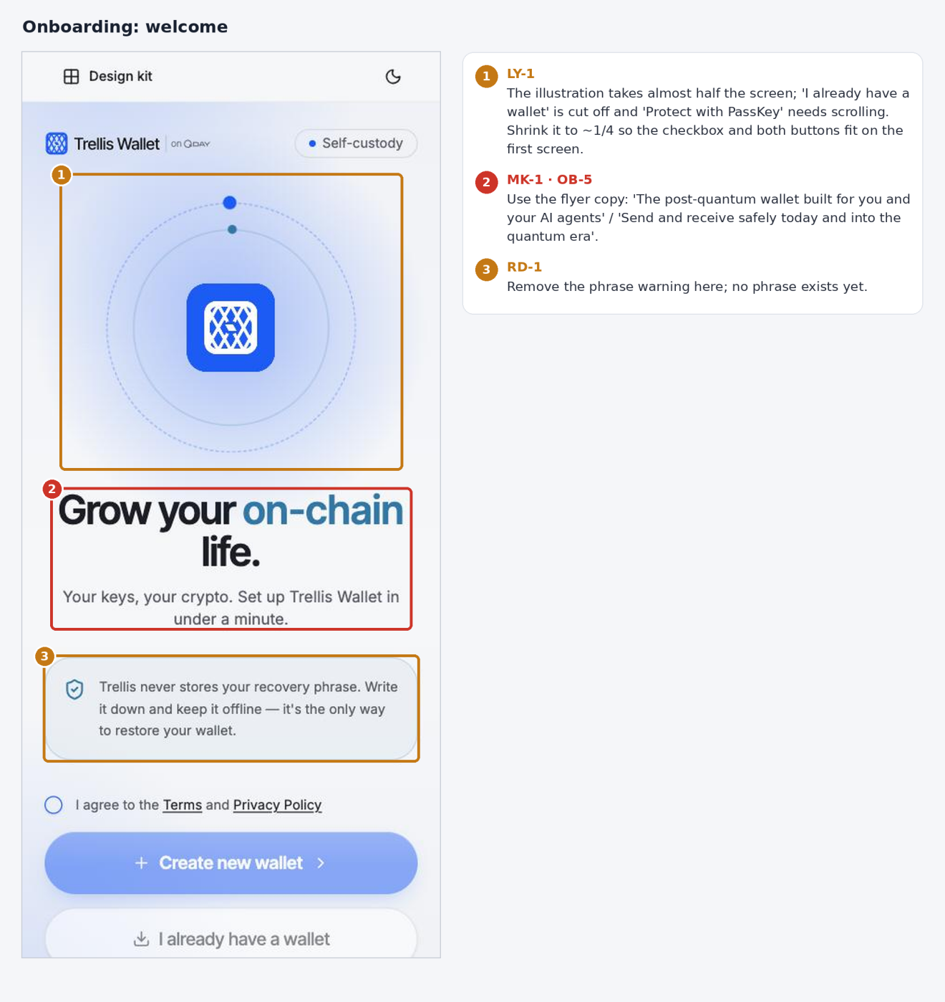
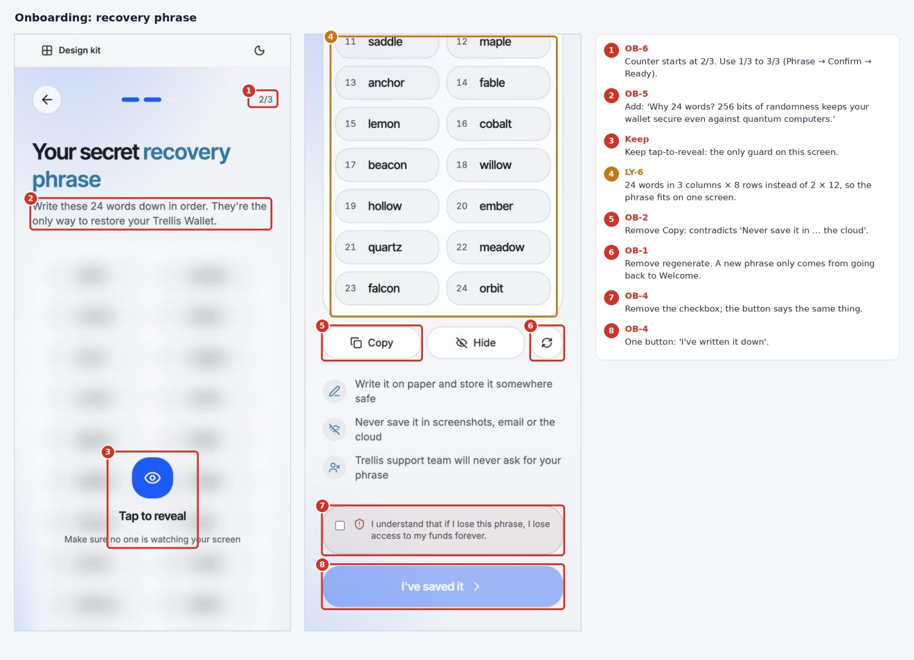
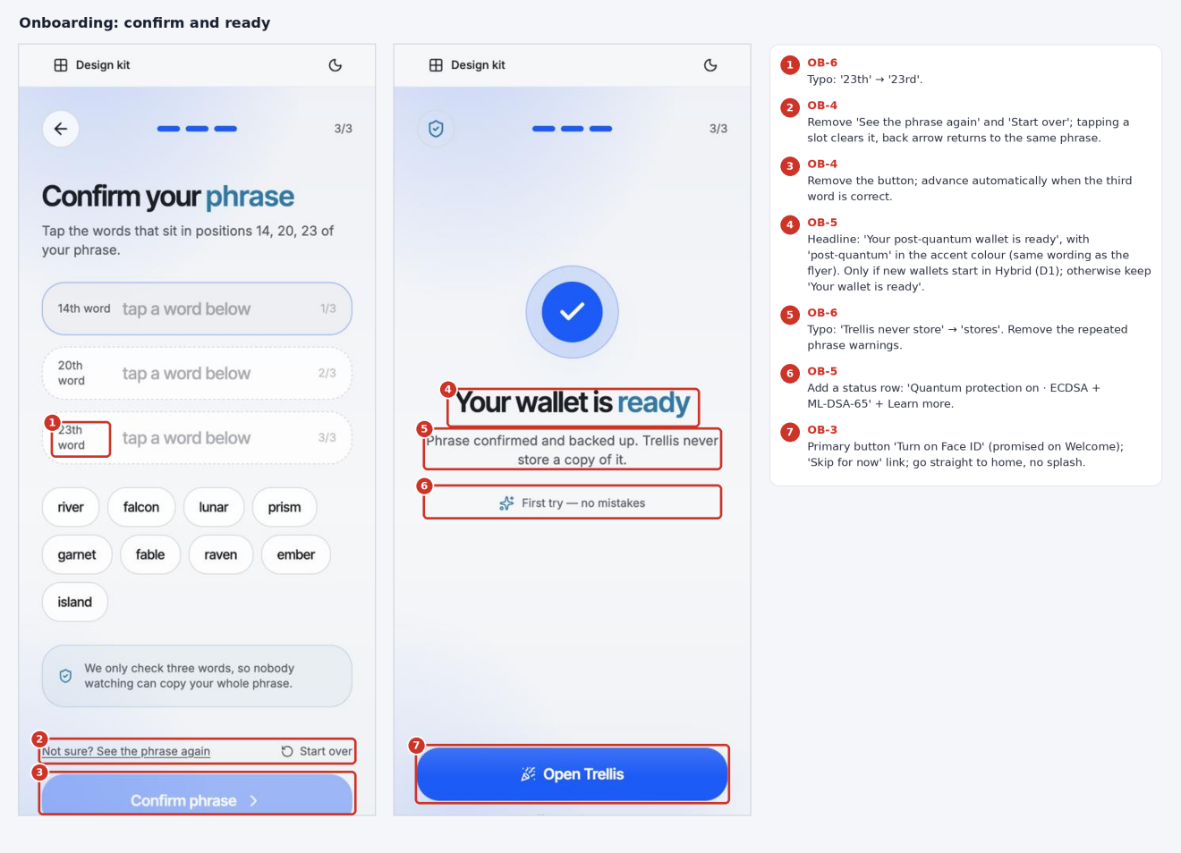

Home
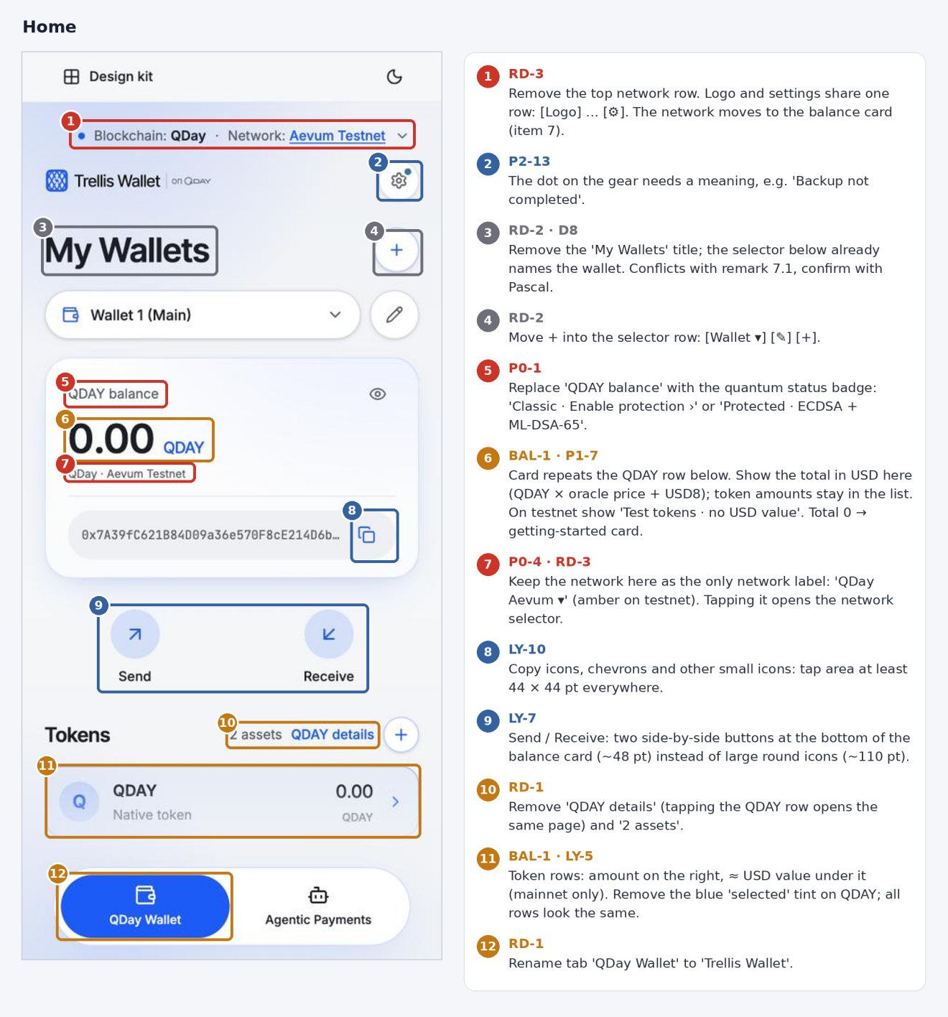
Proposed top of home (RD-2, RD-3, BAL-1, P0-1): the top network row is gone; logo and settings share one row; the network chip sits in the balance card under the USD total and opens the network selector. Left: mainnet. Right: testnet, where the total shows "$ —" because test tokens have no USD value.
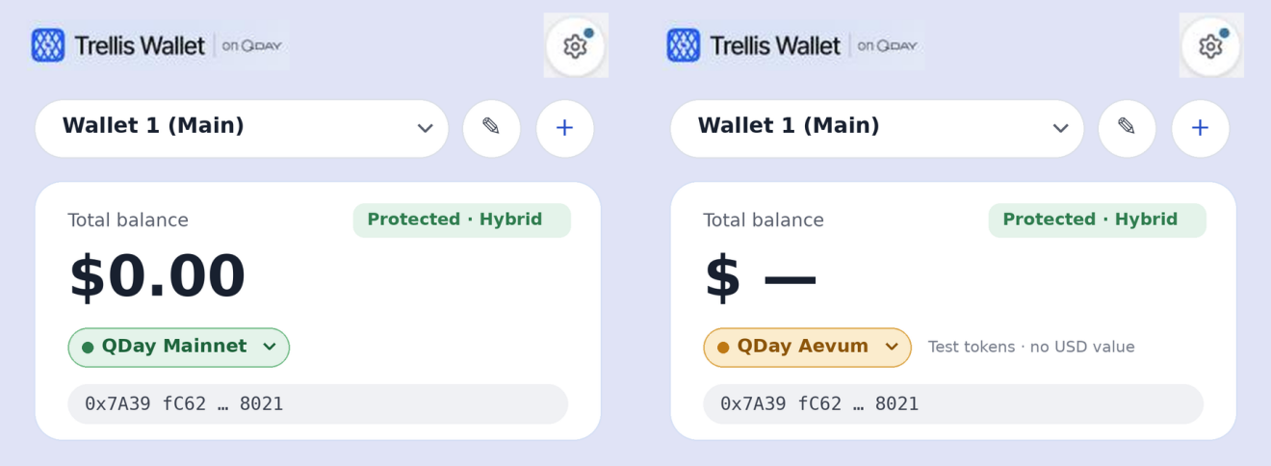
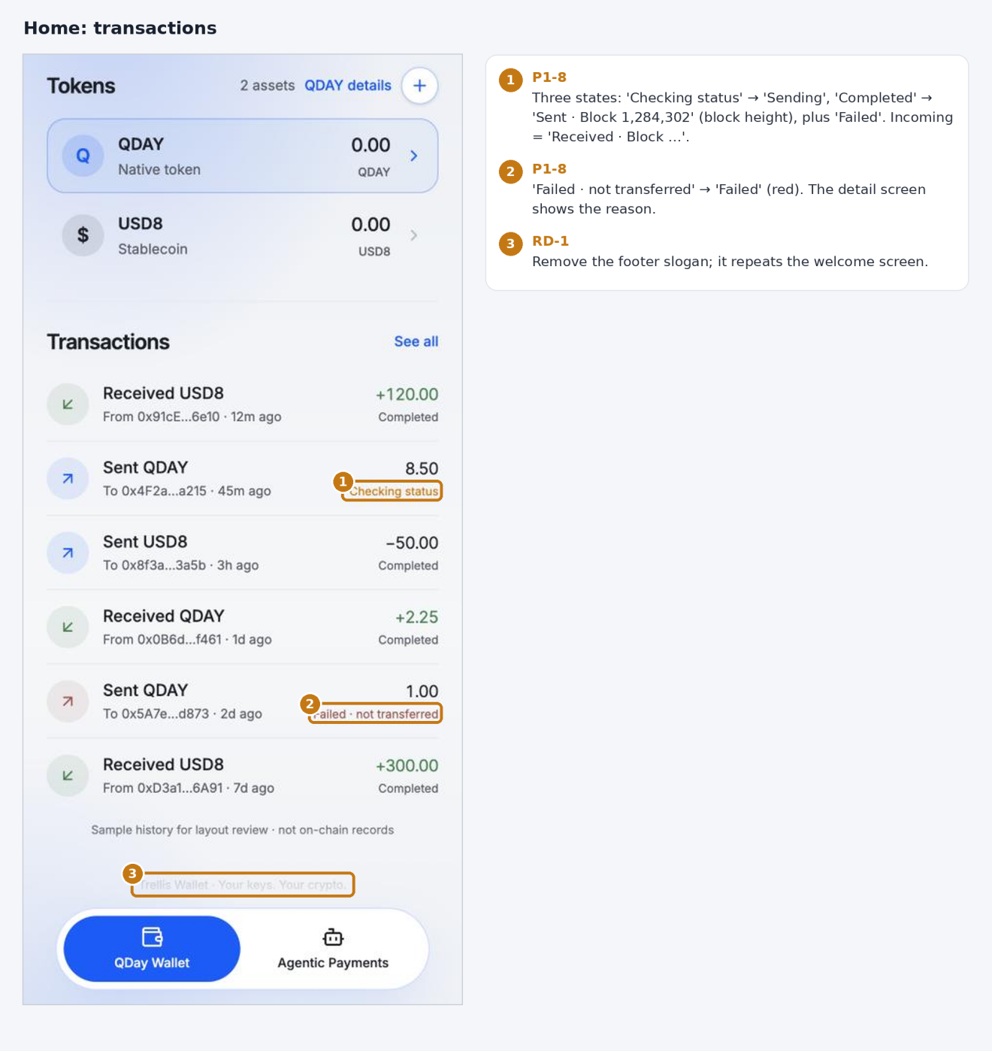

Send, receive and transactions
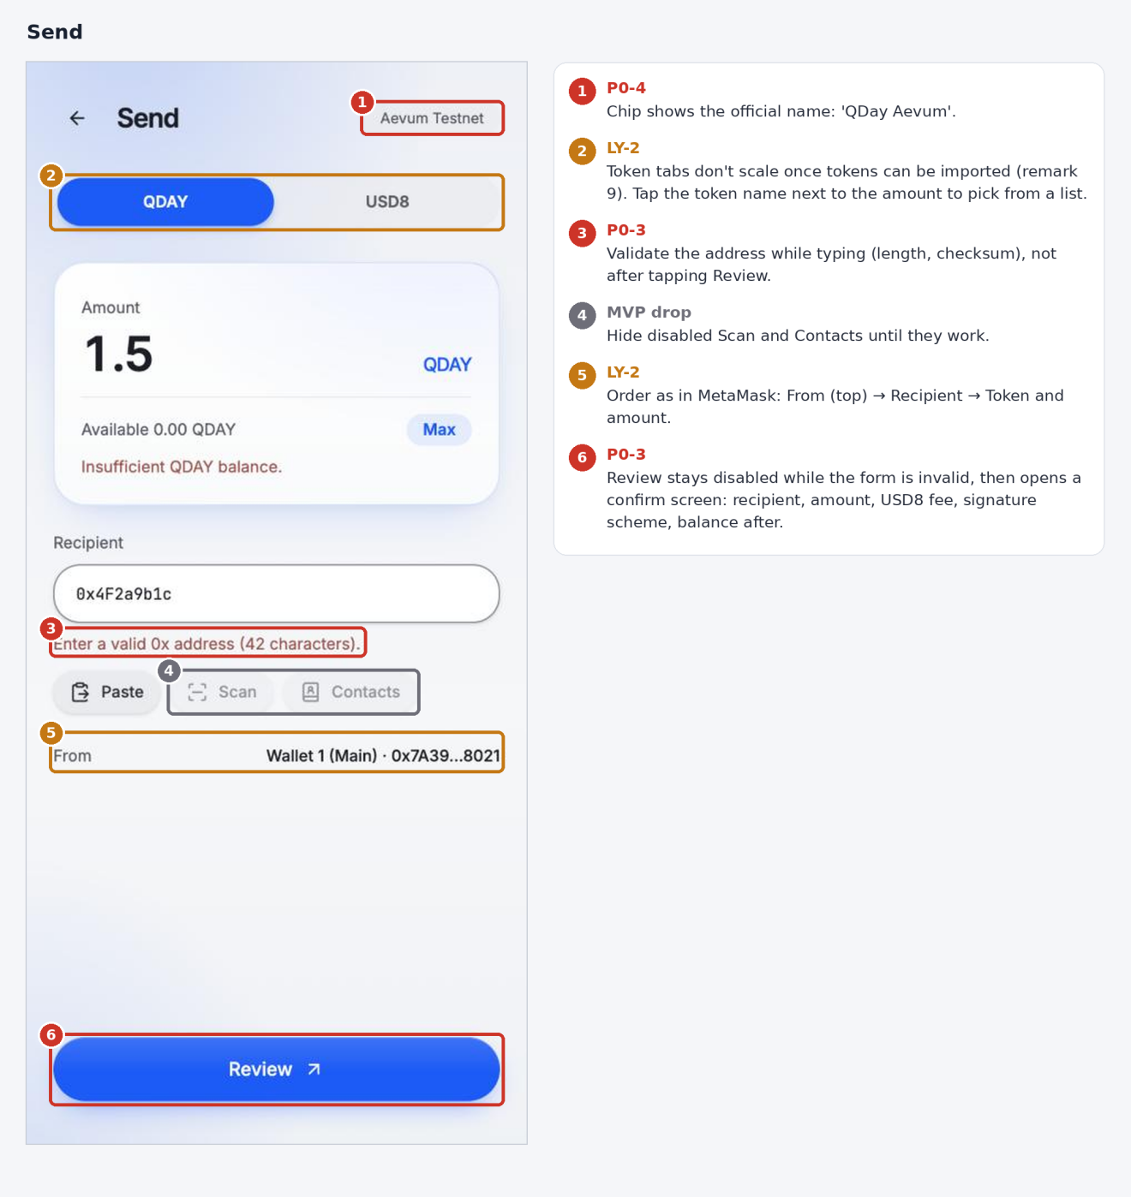
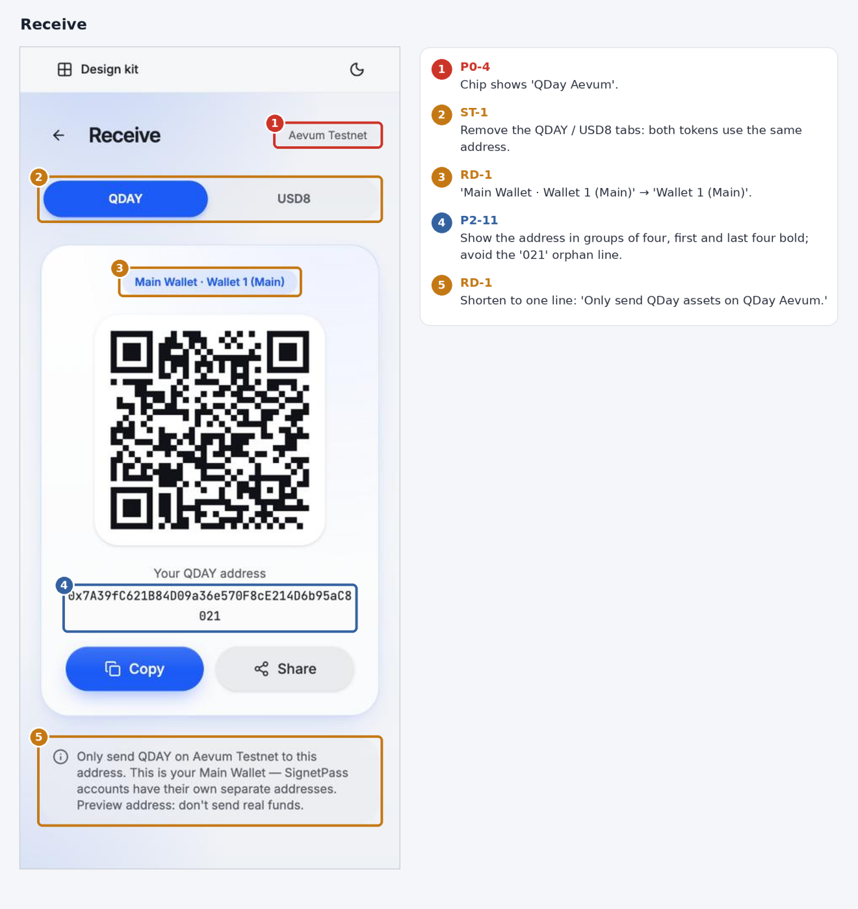
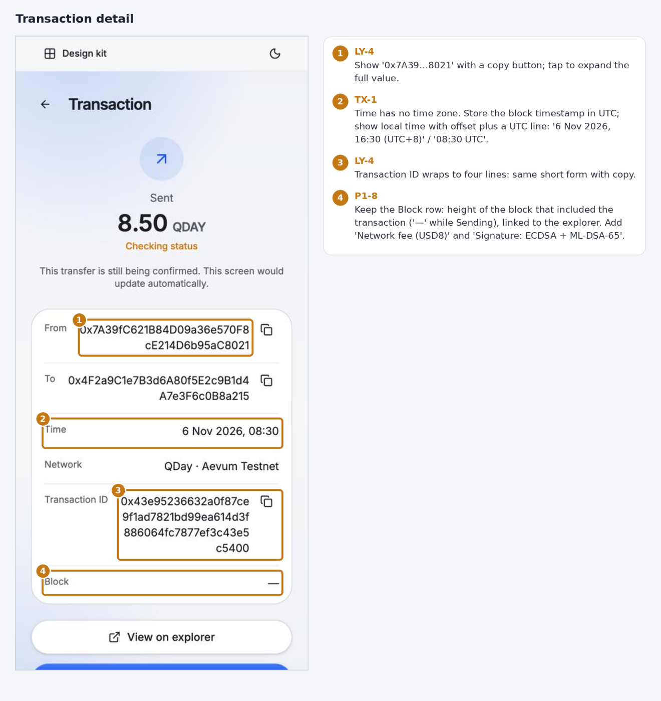

Network and quantum protection
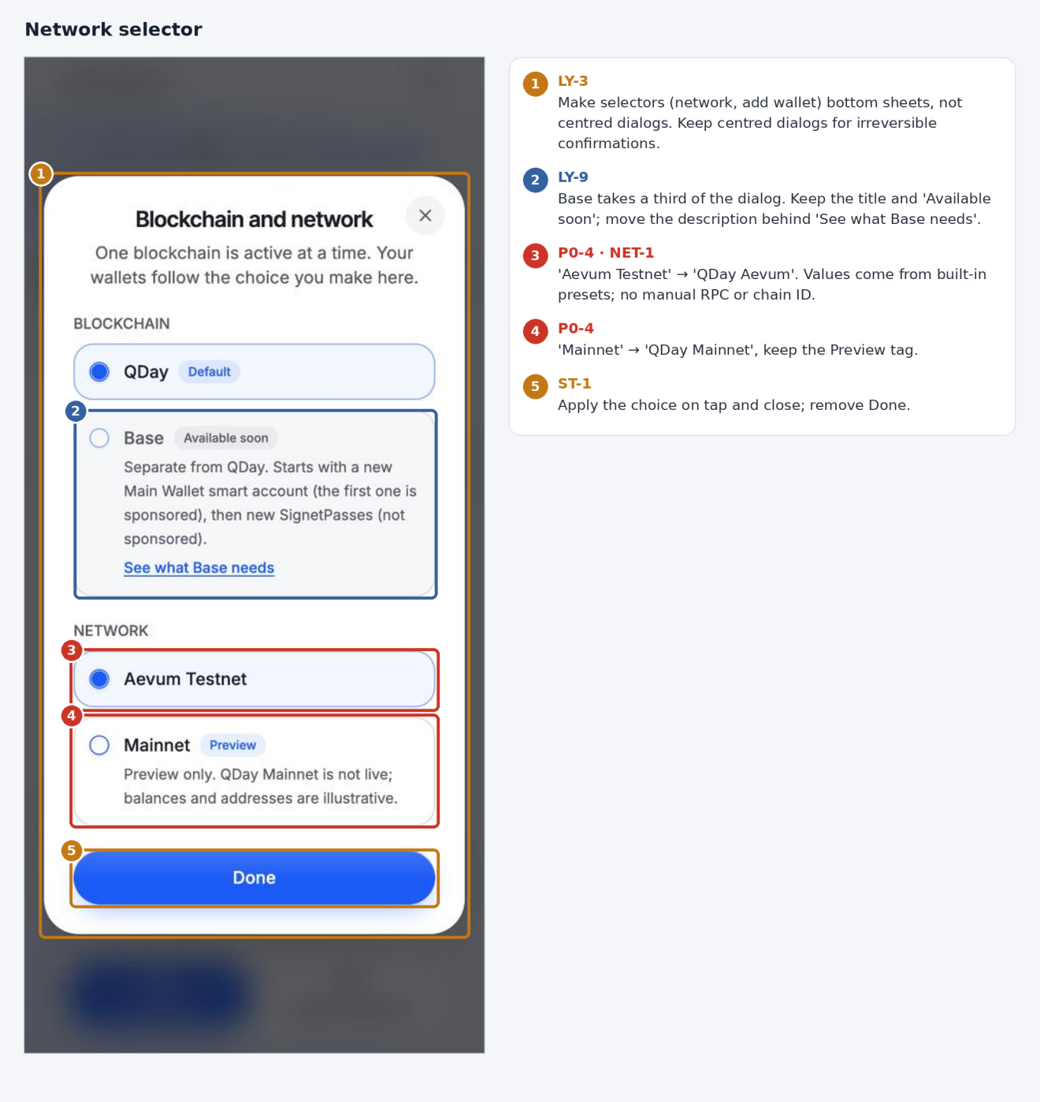
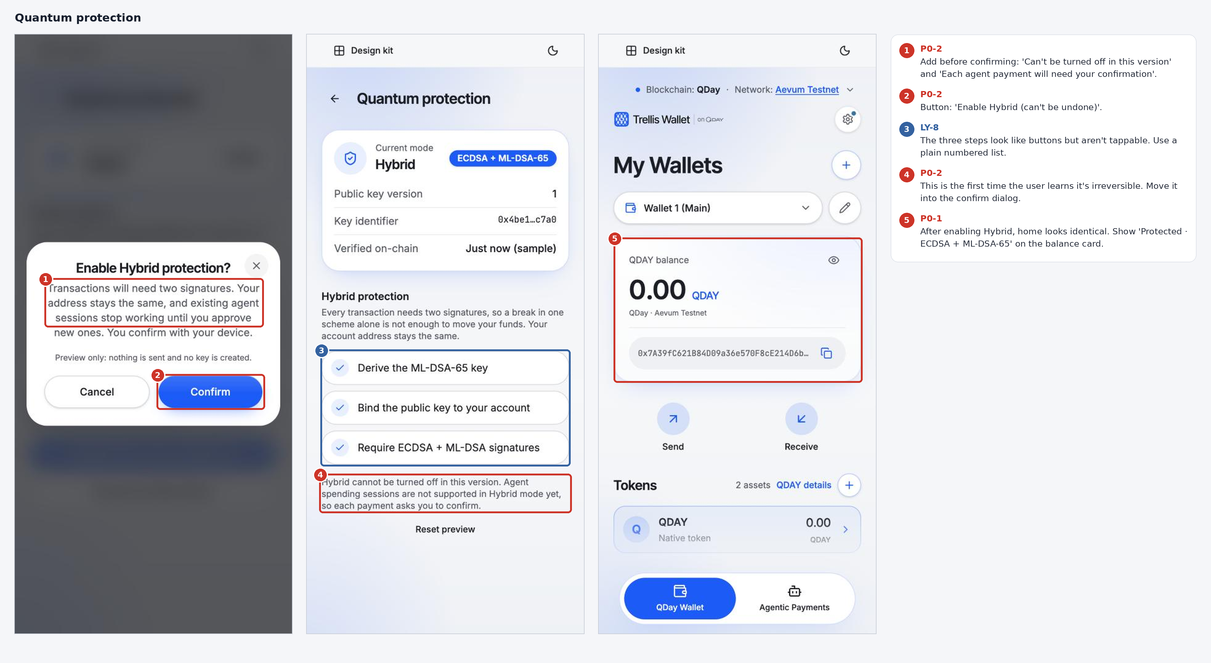

Account, assets and settings
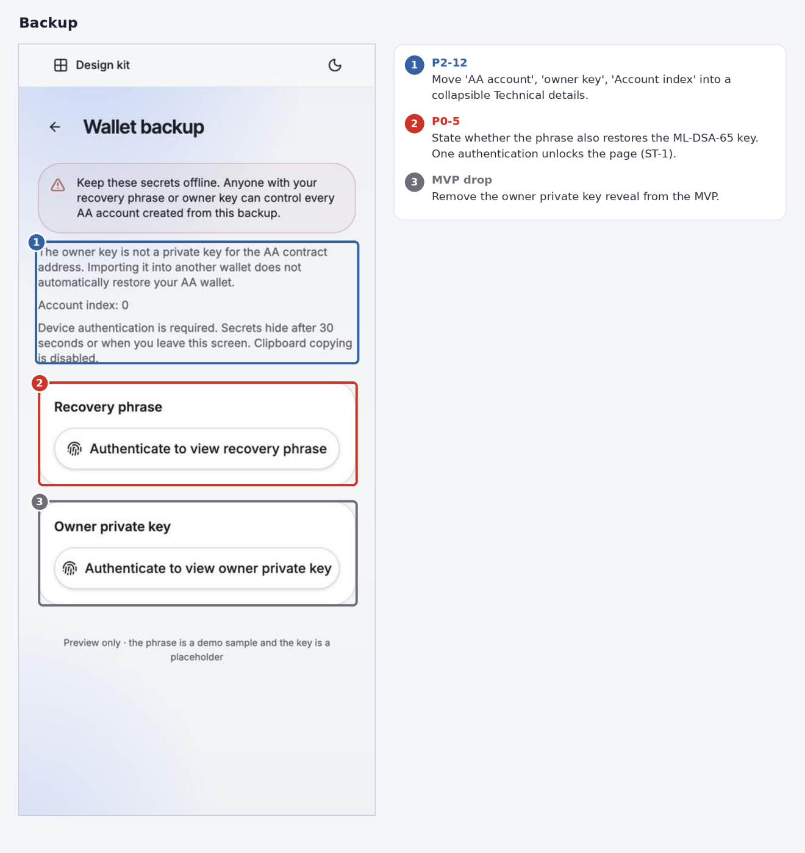
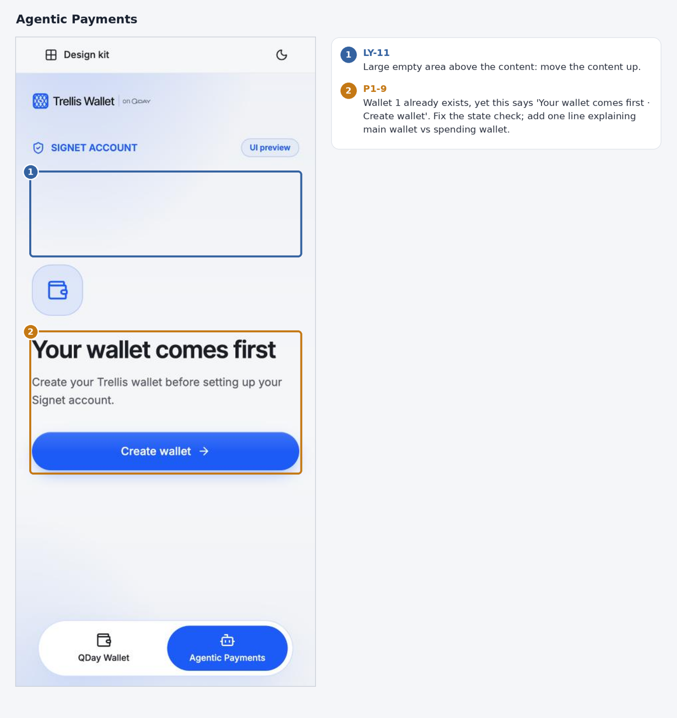
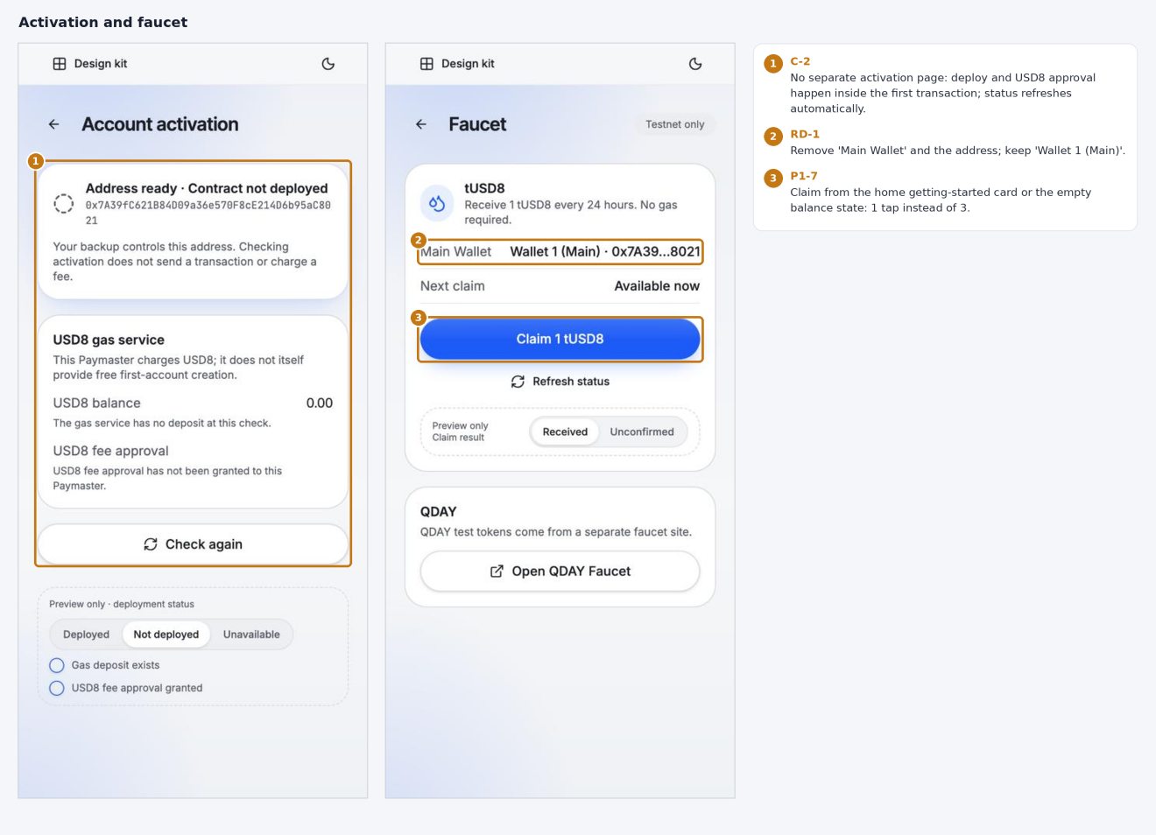
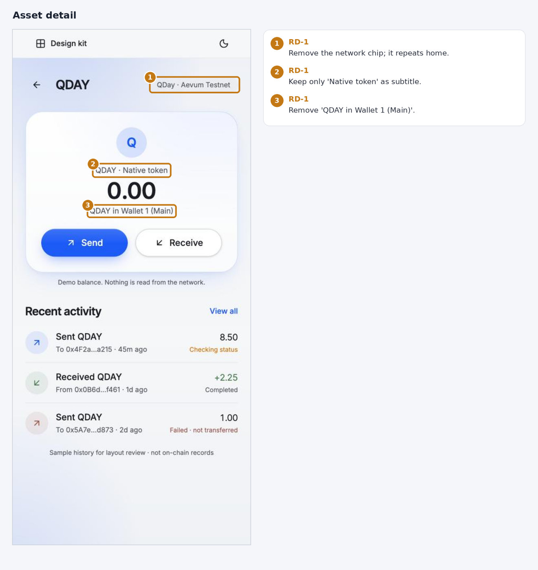
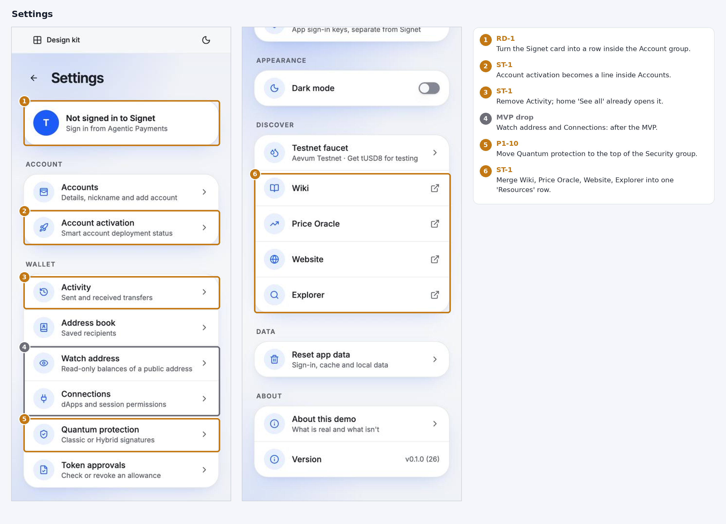

MVP onboarding flow
The MVP onboarding can run with no backend at all. The phrase, both keys and the account address are generated on the device, and the account contract deploys with the first transaction. The proposed flow has four screens, follows MetaMask's order, and mentions quantum protection in three places.

Issues in today's onboarding (23–28)
The flow is solid: phrase hidden until tapped, a three-word check and a clear success screen. Five issues need fixing:
- The promised Passkey step never comes. The welcome screen says "Protect with PassKey after setup", but 28 goes straight to "Open Trellis" and the home screen. Add a Passkey step between 27 and 28, with a Skip option.
- Copy contradicts the safety tips. 25 offers a Copy button right above "Never save it in screenshots, email or the cloud", and the backup page (18) says clipboard copying is disabled. Remove Copy here.
- Remove "New phrase". The refresh icon next to Hide regenerates the phrase, even after the user may have written it down. MetaMask has no such button. A new phrase should only come from going back to the welcome screen and creating again.
- The step counter starts at 2/3. The welcome screen isn't a step, so the counter jumps to 2. Count Phrase → Confirm → Passkey as 1/3 to 3/3.
- Typos. "23th word" should be "23rd word". "Trellis never store a copy" should be "stores". The ready screen's page title still reads "Confirm Phrase".
Onboarding also never mentions quantum protection. The MVP onboarding flow below adds it.

Compared with MetaMask
Step | MetaMask | Trellis MVP
Start | "Create a new wallet" or use an existing one, then choose a Secret Recovery Phrase or social login (Google, Apple, Telegram; extension only) | Welcome screen: "I agree", then "Create new wallet" or "I already have a wallet" (remark 5). No social or email login in the MVP
Lock | Set a password | No password. Device biometrics are offered on the last screen, so there is nothing to store, reset or sync
Phrase | 12 words, blurred until tapped, no regenerate button | 24 words, blurred until tapped, no Copy, no regenerate button, one line on quantum security
Confirm | Fill in missing words | Pick three words; auto-advance when the third is correct
Finish | Success screen | Success, quantum protection status, Face ID / Touch ID, Skip → home
The first two MetaMask steps follow its help page; the later steps reflect the current apps and may change between releases.

Screen by screen
- Welcome. Headline and subline from the flyer: "The post-quantum wallet built for you and your AI agents" and "Send and receive safely today and into the quantum era". Keep the "I agree" checkbox and the two buttons (remark 5). Drop the phrase warning card, since no phrase exists yet.
- Recovery phrase (1/3). "Write down these 24 words in order." Quantum line: "Why 24 words? 256 bits of randomness keeps your wallet secure even against quantum computers." If the phrase also re-derives the ML-DSA-65 key (P0 item 5), add: "These words also restore your post-quantum key." Tap to reveal and Hide stay. Keep the three tips, including "Trellis support team will never ask for your phrase" (remark 7). One button: "I've written it down". No Copy, no regenerate, no checkbox.
- Confirm (2/3). Three positions, for example 14, 20 and 23. Tapping a filled slot clears it. The screen advances on its own when the third word is correct; a wrong word shakes and says which position is wrong. The back arrow returns to the same phrase. Drop "Start over" and "Not sure? See the phrase again".
- Ready (3/3). "Your post-quantum wallet is ready", with "post-quantum" in the accent colour (if new wallets start in Hybrid, D1; otherwise "Your wallet is ready"). A status row: "Quantum protection on · ECDSA + ML-DSA-65", with Learn more opening a two-sentence explanation. Primary button "Turn on Face ID" (or Touch ID); a "Skip for now" link goes straight to home with no splash.
The phrase is generated once, in memory, when the user taps "Create new wallet". Going back from Confirm shows the same phrase. Going back to Welcome discards it, and the next "Create new wallet" generates a new one. That is the only way to get a new phrase. The phrase is written to encrypted device storage only after the Confirm step, and never reaches the backend.
One decision is needed before the Ready screen can say "Quantum protection on". The prototype states that agent spending sessions don't work in Hybrid mode yet (15). If new wallets start in Hybrid, that limit applies from day one. Confirm with the contracts team whether SignetPass spending wallets are affected by the main wallet's signature mode. If they aren't, start new wallets in Hybrid. If they are, start in Classic and keep the upgrade flow for later.

What the MVP can drop
Each item below is code to build, test and maintain without changing what a first-time user can do. Flows set by Pascal stay: Import token (remark 9), Base shown as "Available soon" (remark 7.4), multiple wallets (remark 7.2) and the SignetPass flows (remarks 11–21).
Feature | What it costs | MVP instead
Regenerate phrase | Confirm must track which phrase is current; extra analytics and test paths | Back to Welcome, then create again
Copy phrase | Clipboard clearing and platform differences; contradicts the safety tips | Removed
"Start over" and "See the phrase again" on Confirm | Two more navigation paths to test | Tap a slot to clear it; back arrow
Phrase acknowledgement checkbox | Extra state to enable the button | Button label "I've written it down"
Classic → Hybrid upgrade flow (12–15) | On-chain migration transaction, progress states, preview and reset, agent-session invalidation | New wallets start in Hybrid; Settings shows the mode read-only (subject to the decision above)
Full post-quantum mode | A third verifier path | After the MVP; align the flyer
Email login, 2FA, social login | Key recovery backend, account service, one-time codes | After the MVP; align the flyer
Server-registered Trellis passkeys (Settings) | WebAuthn server and credential storage | Device biometric unlock only
Account activation page (20) | Polling and three status states | Deploy and approve inside the first transaction
Owner private key reveal (18) | A second secret to protect and explain | Recovery phrase only
Watch address, Connections, Token approvals | A data source and screens each | After the MVP, unless dApp connections ship at launch
Disabled Scan and Contacts buttons (03) | UI that does nothing | Hidden until built
Splash screen (00) | An extra loading state on every page | Home skeleton

Network presets
Trellis Wallet ships with every supported network already configured. Users pick a network by name and never type an RPC URL, chain ID, token symbol or explorer address, and the MVP has no "Add custom network" screen. Only one blockchain is active at a time (remark 7.4); the presets just remove the setup work.
Network | Type | Chain ID | Native token | Default tokens | At launch
QDay Aevum | Testnet | From QDay team (D7) | QDAY | QDAY, USD8 (remark 9) | Default network
QDay Mainnet | Mainnet | From QDay team (D7) | QDAY | QDAY, USD8 | Preview until mainnet (flyer: early 2027)
Base | Mainnet | 8453 | ETH | ETH, USDC (remark 9) | Available soon (remark 7.4)
Base Sepolia | Testnet | 84532 | ETH | ETH, USDC | Available soon
Ethereum | Mainnet | 1 | ETH | ETH, USDC | Decide in D7
Ethereum Sepolia | Testnet | 11155111 | ETH | ETH | Decide in D7
Remark 7.3 uses Holesky as an example Ethereum testnet. Holesky was shut down in 2025, so the preset list uses Sepolia instead.
Each preset carries these fields, so screens read from one source and nothing is hard-coded per screen:
- Display name (the official name, D4) and testnet flag, which drives the amber testnet cue
- Chain ID, plus primary and fallback RPC endpoints
- Explorer URL pattern for addresses and transactions
- Native token symbol and decimals, and the default token list
- Faucet link (testnets only)
- Status: live, preview or available soon
- Whether Hybrid signatures are supported on that network
For the MVP, bundle the presets in the app; that needs no backend. When the app connects, check that the RPC reports the expected chain ID, and refuse to sign if it doesn't. A signed remote config, which would let RPC endpoints change without an app release, can come after the MVP.

Transaction history: time and local cache
Store every time in UTC and show it in the user's local time with the offset written out. Cache the history on the device and sync only what is new.

Time (TX-1)
Two people in different time zones must be able to tell that they are looking at the same moment. Today the detail screen shows "6 Nov 2026, 08:30" with no time zone (17), so a user in UTC+8 and one in UTC−5 can't tell whether they mean the same time. Addresses, amounts and block heights are the same for everyone; only the time display depends on where the user is.
- Store the block timestamp (Unix seconds, always UTC). For a Sending transaction, store the moment the user signed. Never store a formatted local string.
- List: relative time within 24 hours ("12m ago"), then a local date ("6 Nov").
- Detail: local time with the offset, and UTC on a second line: "6 Nov 2026, 16:30 (UTC+8)" / "6 Nov 2026, 08:30 UTC". The UTC line and the block height match the explorer exactly, which helps support and disputes.
- Format dates from the device locale (24-hour vs 12-hour, day-month order), but keep the timestamp itself in UTC.

Local cache (TX-2)
Yes, cache the history on the device. The chain and the indexer stay the source of truth; the cache makes the list appear instantly and cuts indexer calls.
- Key the cache by network + address. Per transaction store: hash, direction, token, amount, counterparty, status, block height, block timestamp, fee.
- Save the last synced block height. On open, show the cache at once, then fetch only transactions after that height.
- Sending transactions exist only in the local cache until they are included. Once the indexer returns them, update them to Sent with block height and timestamp. If the transaction fails, mark it Failed and keep the reason.
- On each sync, re-check the most recent blocks in case of a reorganisation. How many depends on QDay finality; ask the QDay team.
- Keep the latest 200 per address locally; older items load from the indexer on scroll.
- Use the app's encrypted storage. The history is public on-chain, but the cache links all of a user's addresses on one device.
- Clear it with "Reset app data" and when a wallet is removed.

Layout
Eleven layout changes make the first screen of each page show what matters and let the design scale past two tokens. LY-2 and LY-3 change structure; the rest are spacing and component swaps. Each is marked on its screen in Annotated screens.
ID | Change | Screens | Priority
LY-1 | Welcome illustration takes nearly half the screen; "I already have a wallet" is cut off and "Protect with PassKey" needs scrolling. Shrink it to about a quarter so the checkbox and both buttons fit on the first screen | 23 | P1
LY-2 | Send: replace the QDAY / USD8 tabs (they won't fit once tokens can be imported, remark 9) with a token picker opened from the token name next to the amount. Order as in MetaMask: From at the top, then recipient, then token and amount, so the sending wallet is clear at a glance once there is more than one wallet | 03, 04 | P1
LY-3 | Selectors (network, add wallet) open as bottom sheets, not centred dialogs. Irreversible confirmations such as enabling Hybrid stay as centred dialogs | 06, 07 | P1
LY-4 | Transaction detail: show addresses and the transaction ID as "0x7A39…8021" with a copy button; tap to expand. Today they wrap to two and four lines | 17 | P1
LY-5 | Token rows all use the same style. The QDAY row has a blue tint, a border, and a different chevron colour that together look like a selected state | 01 | P2
LY-6 | Recovery phrase in 3 columns × 8 rows instead of 2 × 12, so all 24 words fit on one screen | 25, 26 | P1
LY-7 | Send and Receive as two side-by-side buttons at the bottom of the balance card (about 48 pt) instead of large round icons (about 110 pt) | 01 | P2
LY-8 | Quantum protection steps as a plain numbered list; today they look like tappable buttons | 12, 15 | P2
LY-9 | Network selector: Base keeps its title and "Available soon" tag (remark 7.4); its description moves behind "See what Base needs" | 06 | P2
LY-10 | Tap area of at least 44 × 44 pt for copy icons, chevrons and other small icons | All | P2
LY-11 | Agentic Payments empty state: move the content up; the area above it is empty | 19 | P2
On the transaction detail screen LY-4 replaces P2-11; P2-11 (groups of four) still applies on Receive, where the full address is needed.

P0 recommendations
P0 items affect trust or can cause user error, so they belong in the next iteration.

1. Show quantum protection status on the main path (12, 15, 16)
Quantum protection is Trellis's main differentiator, yet it sits fifth in Settings and defaults to Classic. After enabling Hybrid, the home screen (16) looks the same as before.
- Add a status badge to the balance card. Classic: "Classic signatures · Enable quantum protection ›", linking to the Quantum protection page. Hybrid: "Protected · ECDSA + ML-DSA-65".
- Add a "Signature" row to the send confirm screen and the transaction detail.
- At the end of first-time onboarding, recommend enabling Hybrid instead of leaving users to find it.

2. Disclose irreversibility before the user confirms Hybrid (13, 15)
The confirm dialog (13) mentions two signatures and paused agent sessions. "Hybrid cannot be turned off in this version" and "each payment asks you to confirm" only appear after enabling (15). Users should never learn about an irreversible change after the fact.
- Move both statements into the confirm dialog, plus any fee impact of larger ML-DSA signatures.
- Rename the button to "Enable Hybrid (can't be undone)".
- If the user has active agent sessions, show how many will stop working.

3. Validate the send form live and add a confirm screen (03, 04)
Insufficient balance is flagged instantly, but an invalid address only shows after tapping Review, and Review stays active while the form is invalid.
- Validate the address as it's typed (length, checksum) and show a short form once valid.
- Disable Review until the form is valid, with the reason shown above the button.
- Add a confirm screen: recipient with first and last four characters highlighted, amount, USD8 gas fee, signature scheme, and the balance after sending.

4. Use the official network names in the top label (01, 03, 06)
The top of the wallet shows "Blockchain: QDay · Network: Aevum Testnet". The network name already implies the blockchain, so the label repeats itself.
- Show one label using the official names: QDay Aevum (testnet) or QDay Mainnet.
- Use the same names on the Send and Receive chips and the balance card ("QDay · Aevum Testnet" today).
- Keep the QDay / Base blockchain choice inside the modal, as in remark 7.4.
- Give testnet a persistent color cue (for example amber) so demo balances are never mistaken for real funds.
To align with Pascal: remark 7.3 displays the network as "Aevum Testnet" / "Mainnet", while the official names are "QDay Aevum" / "QDay Mainnet".

5. Explain what the backup restores, including the quantum key (18)
The backup page says the owner key alone won't restore the AA wallet, but never says whether the recovery phrase restores the ML-DSA-65 key. If a user enables Hybrid and loses the device, that is the question that matters.
- State plainly whether the recovery phrase re-derives the ML-DSA-65 key.
- If it doesn't, add a separate backup step and show it before Hybrid can be enabled.

P1 and P2 recommendations
P1 items make onboarding easier; P2 items are polish.
# | Priority | Recommendation | Screens
7 | P1 | Getting-started checklist on home. A collapsible card under the balance: (1) claim test tokens, (2) hold enough USD8 for the SignetPass deployment fee (remark 11), (3) enable quantum protection. Each step ticks off when done. | 01, 21
8 | P1 | Three transaction states. Outgoing transfers show "Sending", "Sent" or "Failed"; incoming ones show "Received". Replace "Checking status" with "Sending" "Completed" with "Sent", and "Failed · not transferred" with "Failed" (the detail screen gives the reason). Once included, show the block height: "Sent · Block 1,284,302" in the list, and a Block row on the detail screen linked to the explorer ("—" while Sending). No confirmation counts or progress steps. Add USD8 gas fee and signature scheme rows to the detail screen. | 17
9 | P1 | Agentic Payments state check. With Wallet 1 (Main) already present, the tab still says "Your wallet comes first · Create wallet". Fix the state check, and note that agent sessions are paused in Hybrid mode. | 19
10 | P1 | Move Quantum protection into the Security group. Place it first under Security, next to Biometric unlock and Recovery phrase. | 10
11 | P2 | Grouped address display. The Receive address wraps after "…aC8", leaving "021" alone on a line. Show it in groups of four with the first and last four characters bold. | 05, 17
12 | P2 | Plain-language backup page. Move "AA account", "owner key" and "Account index" into a collapsible Technical details section. | 18
13 | P2 | Explain the Settings badge. The dot on the gear icon has no stated meaning. Tie it to a specific to-do, such as "Backup not completed". | 01, 10
14 | P2 | Skeleton instead of splash. Every page load shows a 1–2 s full-screen logo. A home skeleton feels faster. | 00

Steps to remove or merge
Across the main flows, about a third of the taps can go without losing any safety check. The biggest win is quantum protection: if new wallets bind the ML-DSA-65 key when the account contract is first deployed, users get Hybrid with no extra steps and no separate upgrade transaction. Tap counts below come from walking through the prototype; flows set by Pascal's remarks (adding a wallet, SignetPass activation) are left as specified.
Flow | Today | Remove or merge | After
First-time onboarding (23–28) | 10 taps over 4 screens, plus the missing Passkey step (11 taps, 5 screens) | Drop the "I understand…" checkbox, since "I've saved it" says the same thing. Auto-advance once the third word is correct, with no "Confirm phrase" button. Merge the Ready screen into the Passkey step: success message at the top, Passkey button below, Skip as a link. Go straight to home with no splash. | 8 taps, 4 screens, Passkey included
Enabling quantum protection (12–15) | 4 taps from Settings, then an upgrade transaction | New wallets: a Hybrid switch, on by default, on the Passkey step. The account contract isn't deployed yet (20), so the ML-DSA-65 key can be bound in the deployment transaction. Existing wallets keep today's flow. | 0 extra taps, no extra transaction
Signing in Hybrid mode | Not shown | One biometric or Passkey approval must produce both the ECDSA and ML-DSA signatures. Never ask twice. | 1 approval per transaction
Main wallet activation (20) | A separate status page with Paymaster deposit, USD8 approval and "Check again" | Batch deployment and the USD8 approval into the user's first outgoing transaction; the confirm screen shows one combined fee. Refresh status automatically instead of "Check again". | No dedicated step
Claiming test tokens (21) | 3 taps via Settings → Discover, with the QDAY faucet on a separate site | Claim from the empty balance state or the getting-started card (item 7). | 1 tap
Switching network (06) | 3 taps: label, option, Done | Apply the choice on tap and close the modal; drop Done. | 2 taps
Receiving (05) | 2 taps: Receive, then a token tab | Remove the token tabs, since both tokens share one address. | 1 tap
Importing a wallet (09) | 2 steps: Recovery phrase → Name | Auto-name it "Wallet <#>" with a pen to rename, the same as creating a wallet (remark 7.2). Drop the Name step. | 1 step
Viewing the backup (18) | One authentication per secret (phrase, then owner key) | Authenticate once for the page. Move the owner private key under Advanced, since most users never need it. | 1 authentication
Transaction detail (17) | Back arrow and a full-width Done button do the same thing | Keep the back arrow. | 1 control
Settings (10, 11) | 21 rows in 7 groups | Activity duplicates "See all" on home. Account activation becomes a line inside Accounts. Wiki, Price Oracle, Website and Explorer fold into one Resources row. Watch address and Token approvals move to Advanced. | About 15 rows
One trade-off stays open. Some mainstream wallets, MetaMask among them, let people skip the backup and remind them later. That would cut onboarding to about 4 taps, but it puts funds at risk if users ignore the reminder. Keep backup first until there is data on drop-off at the phrase step.
Tap-to-reveal on the phrase screen (24) stays. It costs one tap and is the only guard on that screen: onboarding has no device authentication yet, and the screen opens right after "Create new wallet", often in public. MetaMask, Phantom and Trust Wallet all blur the phrase until the user acts. In the native app, also blur the phrase in the app-switcher snapshot and block screenshots on this screen.

Redundant information
The user already knows they are in a wallet, on QDay, looking at their own account. The home screen still says "wallet" four times, names the network three times and names QDAY five times. The rule to apply: state each fact once, at the level where it can change. Network belongs on the balance card, wallet name in the selector, and the token on its own row.
Items fixed by Pascal's remarks stay as they are, except the "My Wallets" title (RD-2, pending D8): "Wallet <#>" naming, the "Agentic Payments" tab, and the support-team line on the phrase screen.
Screen | What repeats | Keep | Remove or merge
Home (01) | "Wallet" appears 4 times: logo "Trellis Wallet", title "My Wallets", selector "Wallet 1 (Main)", bottom tab "QDay Wallet" | Logo, title, selector | Rename the "QDay Wallet" tab to "Trellis Wallet", and replace "QDay Wallet" with "Trellis Wallet" everywhere in the app
Home (01) | Network appears 3 times: top label, "on QDAY" beside the logo, "QDay · Aevum Testnet" under the balance | Network chip on the balance card | Remove the top network row; keep the network on the balance card as a tappable chip (RD-3). The "on QDAY" lockup is official branding and stays
Home (01, 02) | QDAY appears 5 times: "QDAY balance", unit "QDAY", "QDAY details", token row name, token row unit | Token row | Balance card shows the amount only; drop the "QDAY details" link, since tapping the QDAY row opens the same page; drop "2 assets" when both rows are visible
Home (02) | Slogan repeated: splash "Self-custody on QDay", welcome chip "Self-custody", welcome "Your keys, your crypto", home footer "Your keys. Your crypto." | Welcome screen | Remove the home footer
Receive (05) | "Main Wallet · Wallet 1 (Main)": "Main" and "Wallet" twice in one chip; footer repeats token, network and wallet | "Wallet 1 (Main)" | Drop "Main Wallet ·"; cut the footer to "Only send QDay assets on QDay Aevum"
Receive (05) | QDAY / USD8 tabs, but both tokens use the same address | One address and QR | Remove the token tabs; say once that QDAY and USD8 both arrive here
Asset detail (22) | QDAY appears 4 times: title, "QDAY · Native token", unit, "QDAY in Wallet 1 (Main)"; network chip repeats home | Title, amount | Drop "in Wallet 1 (Main)" and the network chip; keep "Native token" as a subtitle
Faucet (21) | "Main Wallet: Wallet 1 (Main) · 0x7A39…8021" | "Wallet 1 (Main)" | Drop the "Main Wallet" label and the address
Onboarding (23–28) | Phrase warning shown 6 times: welcome card, phrase subtitle, three tips, the checkbox, the ready screen twice | Phrase subtitle, three tips, checkbox | Drop the welcome-card warning (no phrase exists yet) and both lines on the ready screen
Settings (10) | A full-width "Not signed in to Signet" card above everything, pointing to another tab | Signet sign-in in Agentic Payments | Turn it into a row inside the Account group
Home (01) | "My Wallets" title above the selector that already reads "Wallet 1 (Main)"; the largest text on the screen says nothing new | Selector, pen and + buttons (remark 7.2) | Remove the title; one row: [Wallet 1 (Main) ▾] [✎] [+]. Conflicts with remark 7.1, see D8
Home (01) | The network appears both in a top row and on the balance card | Logo, network chip, settings | Remove the top row; top bar is [Logo] … [⚙]; the network chip lives on the balance card (RD-3). Together with RD-2 this frees about 100 pt above the balance
Home (01) | The balance card shows "0.00 QDAY", the same number as the QDAY row in the token list | Token list with per-token amounts | Card shows the USD total of all tokens (BAL-1); on testnet it says "Test tokens · no USD value"
Removing these frees vertical space on home and moves the transaction list closer to the first screen.

Messaging consistency with the flyer
The app and the CVCF 2026 flyer describe two different products. The flyer sells "the post-quantum wallet built for you and your AI agents". The app's welcome screen says "Grow your on-chain life" and never mentions quantum security or agents. Five gaps, ordered by how visible they are:
Topic | Flyer says | App shows | Recommendation
Positioning (23) | "Control." · "The post-quantum wallet built for you and your AI agents" · "Send and receive safely today and into the quantum era" | "Grow your on-chain life." · "Your keys, your crypto. Set up Trellis Wallet in under a minute."; splash: "Self-custody on QDay" | Reuse the flyer's headline and subline on the welcome and splash screens
Signature modes (12–15) | Three modes: Classic (ECDSA), full post-quantum (ML-DSA-65), Hybrid | Two modes: Classic and Hybrid; Hybrid "cannot be turned off" | Add the full post-quantum mode, or confirm with marketing that the flyer should say two modes
Sign-in (23–28) | Email login, passkey and biometrics, 2FA, or a seed phrase | Seed phrase only; the promised Passkey step is missing | Offer the sign-in choices on the welcome screen, or narrow the flyer to what ships at launch
Two wallets in one (01, 19) | A main wallet for you and a spending wallet for your agents | Both exist (Main Wallet, SignetPass spending wallet) but the app never explains the pair | One line on the welcome screen and on the empty Agentic Payments tab: "Your main wallet holds your funds; spending wallets let agents pay within limits you set"
Gas abstraction (20) | Listed as a feature | Shown as Paymaster deposits and USD8 approvals to configure in Settings | Present it as a benefit ("pay fees in USD8"), with the setup inside the getting-started checklist (item 7)
Two items already match: the "Trellis Wallet | on QDAY" logo lockup and "Mainnet early 2027" against the app's "Mainnet · Preview" label. The safety line differs: the flyer says "QDay will never ask for your private key or seed phrase", while remark 6 sets "Trellis support team will never ask for your phrase". Marketing and product should pick one.

Suggested rollout
Bundle items 1–5 with the V1.0 remarks in the next build, then take 7–10, and fold 11–14 in as polish when those screens are touched. The onboarding fixes and the redundancy clean-up are mostly copy and layout changes and can ship with items 1–5, along with the flyer alignment. Two of the step merges touch contracts (binding the ML-DSA-65 key at deployment, batching activation into the first transaction), so check feasibility with the contracts team first.

Appendix A: Prototype screenshots
The screens are grouped by flow and numbered 00–28. The sections above refer to these numbers.

First-time onboarding
23 Welcome · 24 Recovery phrase, hidden · 25 Phrase revealed · 26 Phrase tips and acknowledgement · 27 Confirm three words · 28 Wallet ready
[image: First-time onboarding screens 23 to 28]

Home and assets
00 Splash · 01 Home, top · 02 Home, tokens and transactions · 22 QDAY asset detail
[image: Home and assets screens 00, 01, 02, 22]

Send and receive
03 Send, empty · 04 Send, validation errors · 05 Receive · 17 Transaction detail, pending
[image: Send and receive screens 03, 04, 05, 17]

Wallet and network management
06 Blockchain and network modal · 07 Add wallet menu · 08 Create wallet · 09 Import wallet
[image: Wallet and network screens 06, 07, 08, 09]

Quantum protection
12 Classic mode · 13 Enable Hybrid confirm · 14 Hybrid in progress · 15 Hybrid enabled · 16 Home after Hybrid is enabled
[image: Quantum protection screens 12 to 16]

Settings and account
10 Settings, top · 11 Settings, bottom · 18 Wallet backup · 19 Agentic Payments · 20 Account activation · 21 Faucet
[image: Settings and account screens 10, 11, 18, 19, 20, 21]

Appendix B: Flow comparison with mainstream wallets
Trellis matches mainstream wallets on receiving, but trails on send confirmation, transaction status and first-funds guidance, and leads on signature security, which no competitor exposes. MetaMask represents EVM multichain wallets, Phantom represents simulation-first wallets, and Coinbase Smart Wallet is closest to Trellis's smart-account architecture.
Flow | Trellis today | MetaMask | Phantom | Coinbase Smart Wallet
Network selection | Small link at top opens a blockchain + network modal (06) | Moving toward multichain accounts with less manual network switching | Unified multichain balances; users rarely pick a network | Handled automatically per app
Send | One form, then Review; address error shows only after tapping Review (03, 04) | Recipient, amount, then a confirm screen with gas estimate and risk alerts | Confirm screen with transaction simulation showing balance changes | Confirm screen; marks gas as sponsored when a paymaster pays
Receive | QR, copy, share and a network warning; address wraps awkwardly (05) | QR + copy, network labelled | Per-chain addresses with QR | One address across Base-ecosystem chains
Transaction status | "Checking status" with no progress, fee or signature info (17) | Pending state in list, with speed-up and cancel | Toast + list status; readable failure reasons | Usually confirms in seconds
Signature security | Classic or Hybrid (ECDSA + ML-DSA-65), set in Settings (12–15) | ECDSA only, not shown | Ed25519 / ECDSA, not shown | Passkey (P-256), not shown
Gas and activation | Activation, paymaster deposit and USD8 approval in Settings (20) | Native token pays gas; insufficient balance flagged inline | Insufficient balance flagged with a top-up prompt | First deployment and gas can be sponsored
Funding an empty wallet | Faucet under Settings → Discover (21); home shows 0.00 with no prompt | Buy / Swap on home | Empty state with a large deposit button | Built-in onramp; empty state prompts a deposit
Competitor flows reflect their public versions as of late 2026 and change between releases.

Appendix C: Scope and method
This review covers 29 screens, including first-time onboarding, of the Trellis Wallet prototype (v0.1.0 build 26), captured on 6 Nov 2026 at a 375 × 812 mobile viewport with the comment overlay hidden.
It complements Pascal L.'s Trellis Wallet Vercel Mockup Review V1.0 (1 Nov 2026). Anything that conflicts with those remarks has been left out. Examples: the "My Wallets" header with + and pen buttons (remark 7), the separate QDay / Base blockchain choice (remark 7.4), removing Buy/Swap (remark 8), and the Agentic Payments / Signet Account / SignetPass naming (remarks 10–16). The recommendations below cover areas the V1.0 remarks don't address.

Sources
- Trellis Wallet prototype
- Pascal L., Trellis Wallet Vercel Mockup Review V1.0, 1 Nov 2026 (internal PDF)
- CVCF 2026 Trellis Wallet A5 flyer (internal PDF)
- MetaMask: Creating a new wallet
- The Block: Ethereum developers to end support for Holesky
- MetaMask: how to change networks
- MetaMask introduces multichain accounts
- Coinbase Smart Wallet
- Transaction simulation guide

